Paleoseismology, active tectonics and archaeoseismology in the Fucino basin

Wegener, A. (1), Lyell, C. (2), Richter, C. (3)

(1) Author address. Email address of corresponding author. Myriad Pro 8 pts-size. Left-tip.
(2) Dept. of Earth & Environmental Sciences, Pukyong National University, Busan 608-737, South Korea. Email: Rsoureh@yahoo.com

Abstract: Herein, we give guidelines that authors will need to put their manuscripts into this final format using MS WORD. The abstract is located two lines below of the last author’s address and the body text will be no longer than 150 words. Myriad pro font style, 9 pts, italic, and single space between lines. If you don’t have Myriad Pro, use Times New Roman instead. We suggest that the abstract includes a brief geographical location, the objective of the work and the most relevant conclusion. Xxxxxxxxxxxxxxxxxxxxxxxxxxxxxxxxxxxxxxxxxxxxxxxxxxxxxxxxxxxxxxxxx
Xxxxxxxxxxxxxxxxxxxxxxxxxxxxxxxxxxxxxxxxxxxxxxxxxxxxxxxxxxxxxxxxxxxxxxxxxxxxxxxxxxxxxxxxxxxxxxxxxxxxxxxxxxxxxxxxxxx
Xxxxxxxxxxxxxxxxxxxxxxxxxxxxxxxxxxxxxxxxxxxxxxxxxxxxxxxxxxxxxxxxxxxxxxxxxxxxxxxxxxxxxxxxxxxxxxxxxxxxxxmaximum size

Key words: 5 words maximum, two lines after the abstract paragraph. Myriad Pro 8 pts-size. Tip- left.

FORMATTING OF RESEARCH PAPERS FOR PUBLICATION

This paper is an example of the final publication format for short research papers that will be published in the proceedings of the 6th International INQUA Meeting on Paleoseismology, Active Tectonics and Archeoseismology, 19-24 April 2015, Pescina, Fucino Basin, Italy (Fig. 1).
Authors should use this example paper, and all of the general formatting (e.g., letter-size paper, 2-column, embedded figures, included-sections, headers, footers, etc.) and specific formatting (e.g., font styles/sizes, spacing, reference styles, etc.) information herein to create a similar-looking document. The main text begins two lines after the key words.

Sections and formats
The following items are required: Header, Title, Authors, Addresses, Abstract, Introduction, Discussion, Acknowledgements, References, and Page numbers. Letter size: Myriad Pro 9 points and single space among lines (1 line). If you don’t have Myriad Pro, please use Times New Roman instead. The text will be distributed in two columns either by using the option of MS WORD code (FORMAT→ COLUMNS), or by pasting the text of your communication to this document. The communication will be as far as 4 pages with complete-tip.

Upper, lower, left and right frames should be of 2 cm. Moreover, 7 mm for binding by using the key Symmetric Frame within the option of Configure Page in File for MS WORD. Paragraphs should be separated by one line and without tab.

With MS WORD, the process of reformatting a single column text document (i.e., .doc file) and separate figures (e.g., .jpg files) into the final double column format with embedded figures (i.e., .pdf file) is straightforward, by using the guidelines and instructions given in this paper. Authors are encouraged to read this paper carefully and follow the guidelines to minimize the effort and time in the review process, to expedite the acceptance of their paper for publication.

Figures at this stage should be clearly readable, for the reviewers, but not of highest resolution, to keep file sizes relative small for rapid upload and download. Authors should have the full-resolution figures available, if requested by editors, and be available for the final formatted paper. However, the print version in hardcopy of the short research communications will be in black and white.
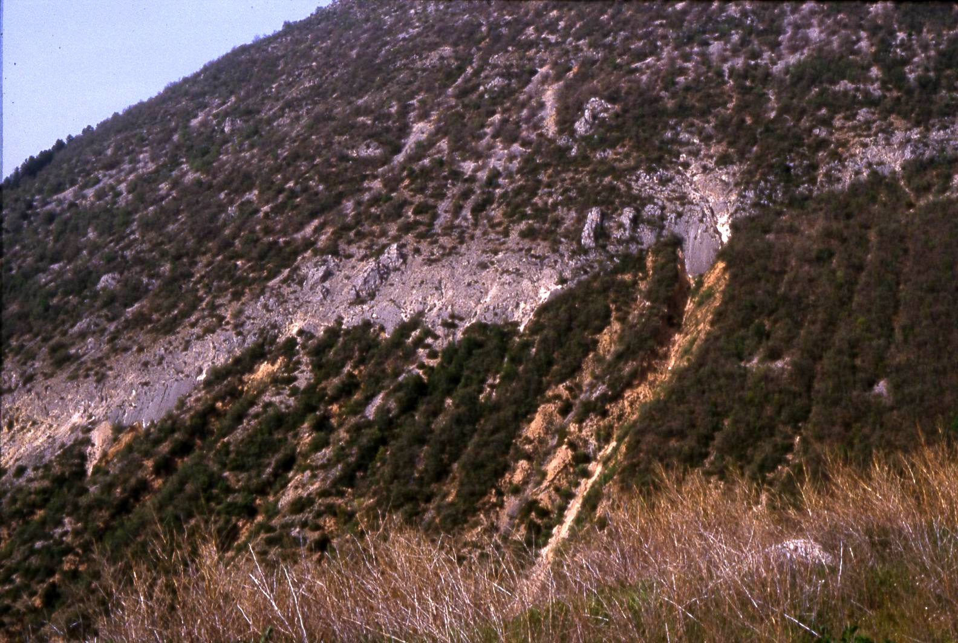

Figure 1: Captions appear related with the figures and with 8 pts. sized. All figures must be referred in the main text (Italic).

We suggest that authors do not include items and sub-items headers. The structure of the short communication could be geographical location, objective and a brief summary with the main conclusions.

Citations and references. If authors are cited directly (e.g., Valverde (2005) says….), then also use the formats of Valverde & Pereiro (2006) and Valverde et al., (1998). If the papers are cited (e.g. …from offshore studies (Reid, 1997), then also use the formats of (Rio & Hernandez, 2004) and (Riera et al., 2011). See the reference section of this draft for examples on the format and style that should be used for the references (i.e., the AGU format). The reference list will be classified by alphabetic name and year of publication.

Best results are achieved when stand-alone figures are in uncompressed formats (e.g., tiff, gif), before they are embedded into the MS WORD document.

Figures should be resized to 300 dpi resolution and the approximate size of 2-column or 1-column width (using Photoshop, or equivalent) before inserting them into the MS WORD document. Copyright release: If authors use figures that are copyrighted, then they must obtain written permission from the copyright holder to use the figure. Authors will be required to sign a copyright release statement saying that they have acquired this permission.

Ensure that text in the figure is readable at the publication size and 300 dpi resolution (minimum 8pts size). Keep in mind that the “distilling process” of creating the final PDF file in the high-resolution “Optimized press” format will degrade the image somewhat. The figures should fit a single column or double column, always according the text box dimensions.

Figures will be published in Black & White in the hard copy of the abstract volume, but authors are required to implement colour figures for electronic version.

By the way, the text percentage of the short research communication will be as short as 60 % of the total space, taking into account the tables, figures and bibliographic references.

Acknowledgements: Brief words given thanks to Projects and supporters. Font style: Myriad Pro 8 pts. One line from the final conclusions and two lines before the references

References
(Bold 9 pts. two lines after acknowledgements or final conclusions).

(References: Single spacing, 8 pts).

Silva, P.G., M.A Rodríguez-Pascua, R. Pérez-López, J.L. Giner-Robles, J. Lario, T. Bardají, J.L. Goy & C. Zazo, (2009). Geological and archaeological record of the 1504 AD Carmona earthquake (Guadalquivir Basin, South Spain): a review after Bonsor, 1918. In: Archaeoseismology and Palaeoseismology in the Alpine-Himalayan Collisional Zone (Pérez-López, R., Grützner, C., Lario, J., Reicherter, K., Silva, P.G. eds). Baelo Claudia, Spain, 139-142.
Hinzen, K.-G., S. Schreiber & B. Yerli, (2010). The Lycian Sarcophagus of Arttumpara, Pinara (Turkey) - Testing Seismogenic and Anthropogenic Damage Scenarios. Bulletin of the Seismological Society of America. 100, (6), 3148-3164.
Nur, A., D. Burgess, (2008). Apocalypse: Earthquakes, Archaeology and the Wrath of God. Princeton University Press. Princeton and Oxford. 309 p.
Stiros, S., (1988b). Archaeology, a tool to study active tectonics – The Aegean as a case study. Eos, Transactions, American Geophysical Union. 13, 1636-1639.

KEY-NOTES:

(1) Papers that do not obey these format instructions will be rejected.

(2) First Paper submission should be always in one unique pdf file.

(3) After acceptance of the papers the editors will require the corresponding formatted word files to the authors (with inset illustrations and tables).

(4) This publication will hold an ISSN number.

